1. 
2. The **first step** to create an Angular App is to lay out the structure of your app and especially plan which components, you probably going to need.   
   Now, it’s normal that when building the app, you decide to add another component which you didn’t plan to add at the beginning.
3. On this page, I’m trying to layout the general structure of our app. So let’s start with the features of this app.
4. Going to have Recipe book and Shopping list. 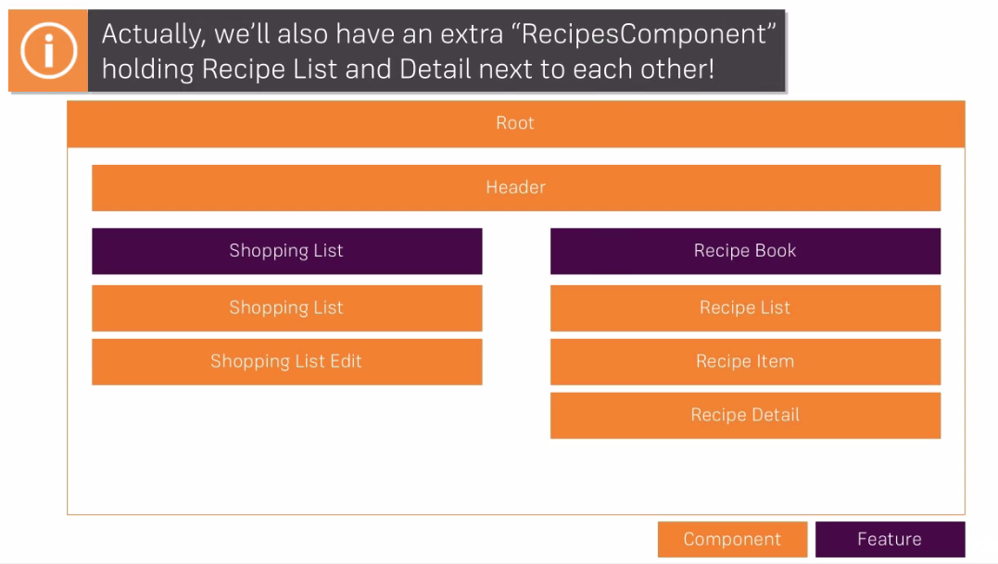
5. Now, one last thing we should think about is which models will be used in this app?
   1. Which model means which data.
6. 